

Practical No.: 9
Aim –
Implement localStorage and sessionStorage to save user preferences like theme settings.
Case Study: Create a Schedule Planner for the given table and show an alert box on click event.
Software/Tools Required –
- VSCode
- Chrome
- HTML5
- CSS3
- Javascript (ES6)
Experiment Program Code –
index.html
<!DOCTYPE html>
<html lang="en">
<head>
<meta charset="UTF-8" />
<meta name="viewport" content="width=device-width, initial-scale=1.0" />
<title>Theme Preferences</title>

<style>
* {
box-sizing: border-box;
}

body {
margin: 0;
min-height: 100vh;
display: flex;
align-items: center;
justify-content: center;
font-family: Arial, sans-serif;

background:
radial-gradient(circle at 15% 20%, #c7d2fe 0%, transparent 30%),
radial-gradient(circle at 85% 80%, #fbcfe8 0%, transparent 30%),
linear-gradient(135deg, #eef2ff, #f8fafc);

color: #1e293b;
transition: all 0.5s ease;
overflow: hidden;
}

body::before,
body::after {
content: "";
position: fixed;
border-radius: 50%;
filter: blur(2px);
z-index: -1;
}

body::before {
width: 220px;
height: 220px;
background: rgba(129, 140, 248, 0.25);
top: -70px;
left: -70px;
}

body::after {
width: 260px;
height: 260px;
background: rgba(244, 114, 182, 0.2);
bottom: -100px;
right: -80px;
}

.container {
width: 90%;
max-width: 570px;
padding: 50px 45px;

text-align: center;

background: rgba(255, 255, 255, 0.72);
backdrop-filter: blur(18px);
-webkit-backdrop-filter: blur(18px);

border: 1px solid rgba(255, 255, 255, 0.7);
border-radius: 28px;

box-shadow:
0 25px 60px rgba(30, 41, 59, 0.15),
inset 0 1px 0 rgba(255, 255, 255, 0.8);

transition: 0.5s ease;
}

.icon {
width: 82px;
height: 82px;

margin: 0 auto 22px;

display: flex;
align-items: center;
justify-content: center;

font-size: 38px;

border-radius: 24px;

background: linear-gradient(
135deg,
#6366f1,
#8b5cf6,
#ec4899
);

box-shadow:
0 12px 30px rgba(99, 102, 241, 0.35);

animation: float 3s ease-in-out infinite;
}

@keyframes float {
0%, 100% {
transform: translateY(0);
}

50% {
transform: translateY(-6px);
}
}

h1 {
margin: 0;

font-size: 32px;
font-weight: 700;

background: linear-gradient(
90deg,
#4f46e5,
#7c3aed,
#db2777
);

-webkit-background-clip: text;
-webkit-text-fill-color: transparent;
}

.subtitle {
margin: 14px auto 34px;

max-width: 430px;

color: #64748b;
font-size: 15px;
line-height: 1.7;
}

.options {
display: flex;
flex-direction: column;
gap: 14px;
}

button {
width: 100%;
padding: 15px 20px;

border: none;
border-radius: 14px;

font-size: 15px;
font-weight: 600;

cursor: pointer;

display: flex;
align-items: center;
justify-content: center;
gap: 10px;

transition: all 0.25s ease;
}

button:hover {
transform: translateY(-3px);
}

button:active {
transform: scale(0.98);
}

.light-btn {
color: #3730a3;

background: linear-gradient(
135deg,
#eef2ff,
#e0e7ff
);

border: 1px solid #c7d2fe;
}

.light-btn:hover {
box-shadow: 0 10px 25px rgba(99, 102, 241, 0.18);
}

.dark-btn {
color: white;

background: linear-gradient(
135deg,
#1e293b,
#334155
);

box-shadow: 0 8px 20px rgba(15, 23, 42, 0.18);
}

.dark-btn:hover {
box-shadow: 0 12px 28px rgba(15, 23, 42, 0.28);
}

.clear-btn {
color: #be123c;

background: rgba(255, 228, 230, 0.7);

border: 1px solid #fecdd3;
}

.clear-btn:hover {
background: #ffe4e6;
box-shadow: 0 8px 20px rgba(244, 63, 94, 0.15);
}

.storage-info {
margin-top: 28px;

font-size: 12px;
color: #94a3b8;
}

.storage-info span {
font-weight: bold;
color: #6366f1;
}

body.dark {
background:
radial-gradient(circle at 15% 20%, #312e81 0%, transparent 30%),
radial-gradient(circle at 85% 80%, #701a75 0%, transparent 30%),
linear-gradient(135deg, #020617, #0f172a);

color: white;
}

body.dark .container {
background: rgba(15, 23, 42, 0.72);

border: 1px solid rgba(148, 163, 184, 0.15);

box-shadow:
0 25px 60px rgba(0, 0, 0, 0.45),
inset 0 1px 0 rgba(255, 255, 255, 0.05);
}

body.dark h1 {
background: linear-gradient(
90deg,
#818cf8,
#a78bfa,
#f472b6
);

-webkit-background-clip: text;
-webkit-text-fill-color: transparent;
}

body.dark .subtitle {
color: #cbd5e1;
}

body.dark .light-btn {
color: #e0e7ff;

background: rgba(79, 70, 229, 0.15);

border: 1px solid rgba(129, 140, 248, 0.3);
}

body.dark .dark-btn {
background: linear-gradient(
135deg,
#f8fafc,
#e2e8f0
);

color: #0f172a;
}

body.dark .clear-btn {
color: #fda4af;

background: rgba(159, 18, 57, 0.18);

border: 1px solid rgba(244, 63, 94, 0.25);
}

body.dark .storage-info {
color: #64748b;
}

body.dark .storage-info span {
color: #818cf8;
}

@media (max-width: 500px) {

.container {
padding: 38px 25px;
}

h1 {
font-size: 27px;
}

.icon {
width: 70px;
height: 70px;
font-size: 32px;
}

.subtitle {
font-size: 14px;
}
}
</style>
</head>

<body>

<div class="container">

<div class="icon">
🎨
</div>

<h1>Theme Preferences</h1>

<p class="subtitle">
Personalize your experience by choosing a theme.
Your preference will be remembered automatically.
</p>

<div class="options">

<button class="light-btn" onclick="setTheme('light')">
☀️
<span>Light Theme</span>
</button>

<button class="dark-btn" onclick="setTheme('dark')">
🌙
<span>Dark Theme</span>
</button>

<button class="clear-btn" onclick="clearPreference()">
↺
<span>Clear Preference</span>
</button>

</div>

<div class="storage-info">
Preference saved using
<span>localStorage</span> &
<span>sessionStorage</span>
</div>

</div>

<script>
function setTheme(theme) {
if (theme === 'dark') {
document.body.classList.add('dark');
} else {
document.body.classList.remove('dark');
}

localStorage.setItem('theme', theme);

sessionStorage.setItem('sessionTheme', theme);
}

function clearPreference() {
localStorage.removeItem('theme');
sessionStorage.removeItem('sessionTheme');

document.body.classList.remove('dark');
}

window.onload = function () {
var saved = localStorage.getItem('theme');

if (saved === 'dark') {
document.body.classList.add('dark');
}
};
</script>

</body>
</html>

Output –

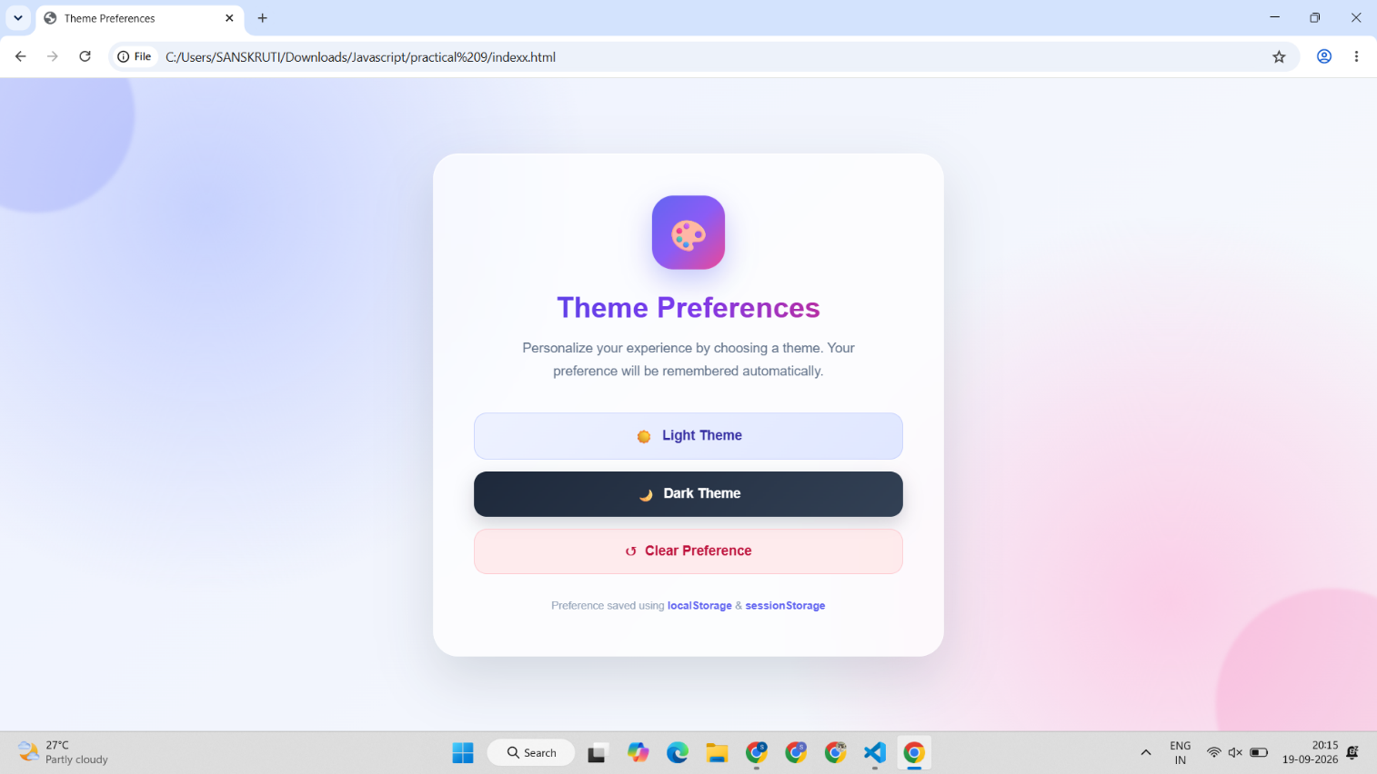
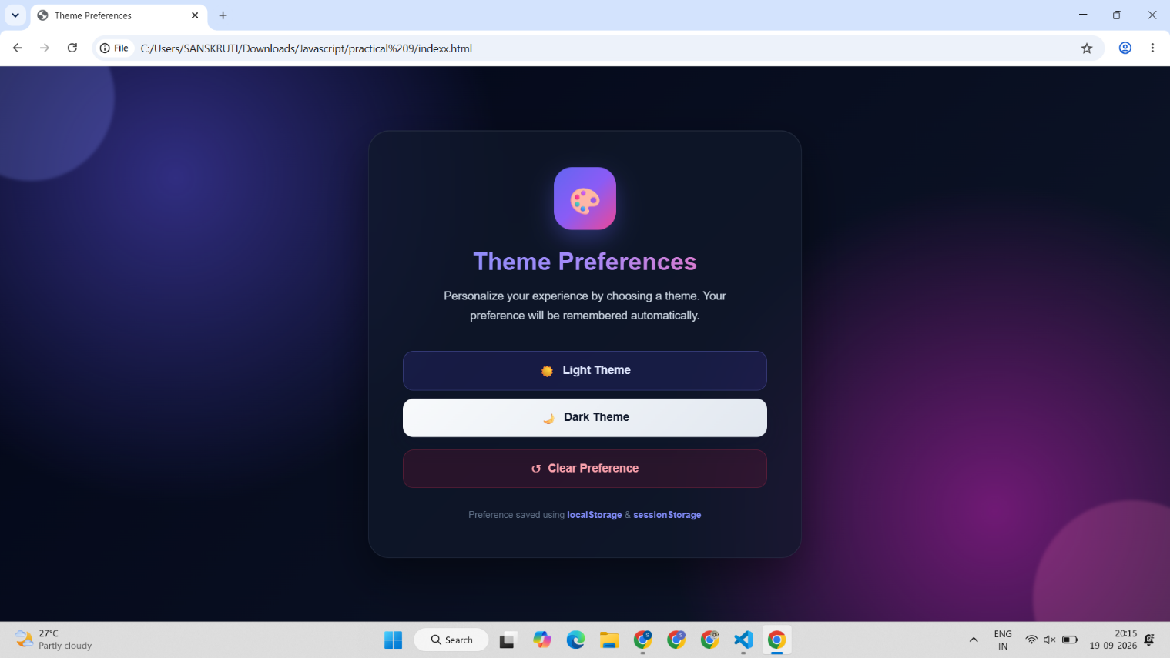
Case Study Title –
Create a Schedule Planner for the given table and show an alert box on click event.
Case Study Program Code –
index.html
<!DOCTYPE html>
<html>
<head>
<title>Schedule Planner</title>

<style>
* {
box-sizing: border-box;
}

body {
margin: 0;
font-family: "Segoe UI", Arial, sans-serif;
background: #f3f1ed;
color: #252333;
padding: 35px 20px;
}

.container {
max-width: 1100px;
margin: auto;
}

.top {
display: grid;
grid-template-columns: 1.05fr 2fr;
gap: 18px;
margin-bottom: 18px;
}

.brand {
background: #29263d;
border-radius: 24px;
padding: 30px;
color: white;
min-height: 190px;
display: flex;
flex-direction: column;
justify-content: space-between;
position: relative;
overflow: hidden;
}

.brand::before {
content: "";
position: absolute;
width: 150px;
height: 150px;
border: 1px solid #ffffff20;
border-radius: 50%;
right: -50px;
bottom: -50px;
}

.brand::after {
content: "";
position: absolute;
width: 80px;
height: 80px;
border: 1px solid #ffffff18;
border-radius: 50%;
right: 5px;
bottom: 5px;
}

.brand small {
color: #b9b3dc;
text-transform: uppercase;
letter-spacing: 2px;
font-size: 10px;
font-weight: 700;
}

.brand h1 {
font-size: 32px;
line-height: 1.05;
margin: 8px 0;
position: relative;
z-index: 1;
}

.brand p {
color: #c9c6d5;
margin: 0;
font-size: 13px;
position: relative;
z-index: 1;
}

.add-panel {
background: #ffffff;
border-radius: 24px;
padding: 27px 30px;
border: 1px solid #e5e1da;
}

.add-heading {
display: flex;
justify-content: space-between;
align-items: center;
margin-bottom: 20px;
}

.add-heading h2 {
margin: 0;
font-size: 18px;
}

.add-heading span {
color: #928d9f;
font-size: 11px;
}

.form-grid {
display: grid;
grid-template-columns: 1fr 1fr 1fr 1.4fr;
gap: 11px;
}

.field label {
display: block;
color: #817d89;
font-size: 10px;
font-weight: 800;
text-transform: uppercase;
letter-spacing: .8px;
margin-bottom: 6px;
}

input {
width: 100%;
height: 43px;
border: 1px solid #dedbe3;
background: #faf9fb;
border-radius: 10px;
padding: 0 12px;
font-size: 13px;
color: #302d3c;
outline: none;
}

input:focus {
background: white;
border-color: #7668d8;
box-shadow: 0 0 0 3px #7668d815;
}

.add-btn {
height: 42px;
margin-top: 15px;
padding: 0 21px;
border: 0;
border-radius: 10px;
background: #7668d8;
color: white;
font-weight: 700;
font-size: 12px;
cursor: pointer;
}

.add-btn:hover {
background: #6557c5;
}

.schedule {
background: white;
border-radius: 24px;
padding: 28px;
border: 1px solid #e5e1da;
}

.schedule-top {
display: flex;
justify-content: space-between;
align-items: end;
margin-bottom: 20px;
}

.schedule-top h2 {
margin: 0;
font-size: 21px;
}

.schedule-top p {
margin: 5px 0 0;
font-size: 12px;
color: #918d99;
}

.storage-badge {
display: flex;
gap: 7px;
}

.badge {
padding: 6px 9px;
border-radius: 7px;
font-size: 9px;
font-weight: 700;
}

.local {
background: #eeeaff;
color: #6255b9;
}

.session {
background: #e8f5ef;
color: #31805c;
}

.table-wrap {
overflow-x: auto;
}

table {
width: 100%;
border-collapse: collapse;
}

th {
text-align: left;
padding: 11px 14px;
color: #9995a0;
font-size: 9px;
text-transform: uppercase;
letter-spacing: 1px;
border-bottom: 1px solid #ece9ee;
}

th:last-child {
text-align: center;
}

td {
padding: 15px 14px;
border-bottom: 1px solid #f0edf1;
font-size: 13px;
cursor: pointer;
transition: .15s;
}

tbody tr:hover td {
background: #fbfaff;
}

tbody tr:last-child td {
border-bottom: 0;
}

.day {
font-weight: 750;
color: #302d3d;
}

.day span {
display: inline-flex;
align-items: center;
gap: 8px;
}

.dot {
width: 7px;
height: 7px;
background: #7668d8;
border-radius: 50%;
}

.time {
color: #656170;
font-weight: 600;
}

.topic {
color: #6558c4;
font-weight: 700;
}

.missing {
color: #cf6872;
font-style: italic;
}

.actions {
text-align: center;
cursor: default;
}

.action {
width: 32px;
height: 32px;
border: 0;
border-radius: 9px;
cursor: pointer;
font-size: 13px;
margin: 0 2px;
}

.edit {
background: #eeeaff;
color: #6255b9;
}

.delete {
background: #fff0f1;
color: #c75b66;
}

.edit:hover {
background: #dfdaff;
}

.delete:hover {
background: #ffe0e3;
}

.empty {
text-align: center;
padding: 40px;
color: #aaa6b1;
font-size: 13px;
}

.edit-box {
display: none;
margin-top: 20px;
background: #f7f5ff;
border: 1px solid #e2def9;
border-radius: 15px;
padding: 20px;
}

.edit-box h3 {
margin: 0 0 16px;
font-size: 15px;
color: #50479b;
}

.edit-grid {
display: grid;
grid-template-columns: 1fr 1fr 1fr 1.4fr;
gap: 11px;
}

.save,
.cancel {
margin-top: 14px;
height: 38px;
border: 0;
border-radius: 9px;
padding: 0 17px;
font-size: 11px;
font-weight: 700;
cursor: pointer;
}

.save {
background: #3d9568;
color: white;
}

.cancel {
background: #e4e1e9;
color: #55515e;
margin-left: 5px;
}

@media (max-width: 800px) {
.top {
grid-template-columns: 1fr;
}

.form-grid,
.edit-grid {
grid-template-columns: 1fr 1fr;
}
}

@media (max-width: 500px) {
body {
padding: 20px 12px;
}

.form-grid,
.edit-grid {
grid-template-columns: 1fr;
}

.brand {
min-height: 160px;
}

.schedule {
padding: 18px;
}

table {
min-width: 700px;
}
}
</style>
</head>

<body>

<div class="container">

<div class="top">

<div class="brand">
<div>
<small>Seminar · 2026</small>
<h1>Schedule<br>Planner</h1>
</div>

<p>Build your timetable one session at a time.</p>
</div>

<div class="add-panel">

<div class="add-heading">
<h2>Add a session</h2>
<span>Enter all four details</span>
</div>

<div class="form-grid">

<div class="field">
<label>Day</label>
<input id="day" placeholder="Monday">
</div>

<div class="field">
<label>Begin</label>
<input id="begin" placeholder="8:00 a.m.">
</div>

<div class="field">
<label>End</label>
<input id="end" placeholder="5:00 p.m.">
</div>

<div class="field">
<label>Topic</label>
<input id="topic" placeholder="Introduction to XML">
</div>

</div>

<button class="add-btn" onclick="addSchedule()">
+ Add session
</button>

</div>

</div>

<div class="schedule">

<div class="schedule-top">

<div>
<h2>Your timetable</h2>
<p>Click a day, time or topic to view session details.</p>
</div>

<div class="storage-badge">
<span class="badge local">LOCAL STORAGE</span>
<span class="badge session">SESSION STORAGE</span>
</div>

</div>

<div class="table-wrap">

<table>

<thead>
<tr>
<th>Day</th>
<th>Begin</th>
<th>End</th>
<th>Topic</th>
<th>Actions</th>
</tr>
</thead>

<tbody id="scheduleBody"></tbody>

</table>

</div>

<div class="edit-box" id="editBox">

<h3>✦ Edit session</h3>

<div class="edit-grid">

<div class="field">
<label>Day</label>
<input id="editDay">
</div>

<div class="field">
<label>Begin</label>
<input id="editBegin">
</div>

<div class="field">
<label>End</label>
<input id="editEnd">
</div>

<div class="field">
<label>Topic</label>
<input id="editTopic">
</div>

</div>

<button class="save" onclick="saveEdit()">
Save changes
</button>

<button class="cancel" onclick="cancelEdit()">
Cancel
</button>

</div>

</div>

</div>

<script>

let editIndex = -1;

window.onload = function() {
displaySchedules();
};

function addSchedule() {

let day = document.getElementById("day").value.trim();
let begin = document.getElementById("begin").value.trim();
let end = document.getElementById("end").value.trim();
let topic = document.getElementById("topic").value.trim();

if (day === "" || begin === "" || end === "" || topic === "") {
alert("Please enter all details.");
return;
}

let schedules =
JSON.parse(localStorage.getItem("scheduleData")) || [];

schedules.push({
day: day,
begin: begin,
end: end
});

localStorage.setItem(
"scheduleData",
JSON.stringify(schedules)
);

let topics =
JSON.parse(sessionStorage.getItem("topicData")) || [];

topics.push(topic);

sessionStorage.setItem(
"topicData",
JSON.stringify(topics)
);

document.getElementById("day").value = "";
document.getElementById("begin").value = "";
document.getElementById("end").value = "";
document.getElementById("topic").value = "";

displaySchedules();

alert("Session added successfully!");
}

function displaySchedules() {

let schedules =
JSON.parse(localStorage.getItem("scheduleData")) || [];

let topics =
JSON.parse(sessionStorage.getItem("topicData")) || [];

let body =
document.getElementById("scheduleBody");

body.innerHTML = "";

if (schedules.length === 0) {

body.innerHTML = `
<tr>
<td colspan="5" class="empty">
No sessions yet. Add your first session above.
</td>
</tr>
`;

return;
}

schedules.forEach(function(schedule, index) {

let row = document.createElement("tr");

let day = document.createElement("td");
day.className = "day clickable";
day.innerHTML =
`<span><i class="dot"></i>${schedule.day}</span>`;

let begin = document.createElement("td");
begin.className = "time";
begin.innerText = schedule.begin;

let end = document.createElement("td");
end.className = "time";
end.innerText = schedule.end;

let topic = document.createElement("td");

if (topics[index]) {
topic.className = "topic";
topic.innerText = topics[index];
} else {
topic.className = "missing";
topic.innerText = "Topic unavailable";
}

let actions = document.createElement("td");
actions.className = "actions";

let edit = document.createElement("button");
edit.className = "action edit";
edit.innerText = "✎";
edit.title = "Edit";

edit.onclick = function(event) {
event.stopPropagation();
editSchedule(index);
};

let del = document.createElement("button");
del.className = "action delete";
del.innerText = "×";
del.title = "Delete";

del.onclick = function(event) {
event.stopPropagation();
deleteSchedule(index);
};

actions.appendChild(edit);
actions.appendChild(del);

row.appendChild(day);
row.appendChild(begin);
row.appendChild(end);
row.appendChild(topic);
row.appendChild(actions);

[day, begin, end, topic].forEach(function(cell) {

cell.onclick = function() {

alert(
"SEMINAR DETAILS\n\n" +
"Day: " + schedule.day + "\n" +
"Begin: " + schedule.begin + "\n" +
"End: " + schedule.end + "\n" +
"Topic: " + (topics[index] || "Topic unavailable")
);

};

});

body.appendChild(row);
});
}

function editSchedule(index) {

let schedules =
JSON.parse(localStorage.getItem("scheduleData")) || [];

let topics =
JSON.parse(sessionStorage.getItem("topicData")) || [];

editIndex = index;

document.getElementById("editDay").value =
schedules[index].day;

document.getElementById("editBegin").value =
schedules[index].begin;

document.getElementById("editEnd").value =
schedules[index].end;

document.getElementById("editTopic").value =
topics[index] || "";

document.getElementById("editBox").style.display =
"block";
}

function saveEdit() {

if (editIndex === -1) {
return;
}

let day =
document.getElementById("editDay").value.trim();

let begin =
document.getElementById("editBegin").value.trim();

let end =
document.getElementById("editEnd").value.trim();

let topic =
document.getElementById("editTopic").value.trim();

if (day === "" || begin === "" || end === "" || topic === "") {
alert("Please enter all details.");
return;
}

let schedules =
JSON.parse(localStorage.getItem("scheduleData")) || [];

schedules[editIndex] = {
day: day,
begin: begin,
end: end
};

localStorage.setItem(
"scheduleData",
JSON.stringify(schedules)
);

let topics =
JSON.parse(sessionStorage.getItem("topicData")) || [];

topics[editIndex] = topic;

sessionStorage.setItem(
"topicData",
JSON.stringify(topics)
);

editIndex = -1;

document.getElementById("editBox").style.display =
"none";

displaySchedules();

alert("Session updated successfully!");
}

function cancelEdit() {

editIndex = -1;

document.getElementById("editBox").style.display =
"none";
}

function deleteSchedule(index) {

if (!confirm("Delete this session?")) {
return;
}

let schedules =
JSON.parse(localStorage.getItem("scheduleData")) || [];

schedules.splice(index, 1);

localStorage.setItem(
"scheduleData",
JSON.stringify(schedules)
);

let topics =
JSON.parse(sessionStorage.getItem("topicData")) || [];

topics.splice(index, 1);

sessionStorage.setItem(
"topicData",
JSON.stringify(topics)
);

displaySchedules();

alert("Session deleted successfully!");
}

</script>

</body>
</html>

Output –
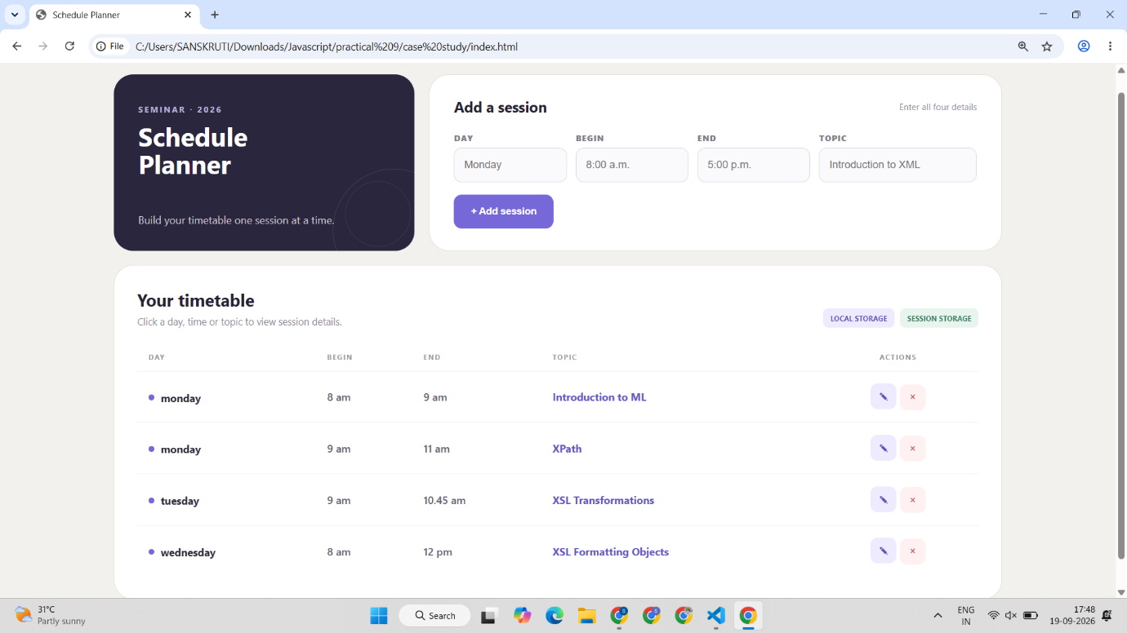
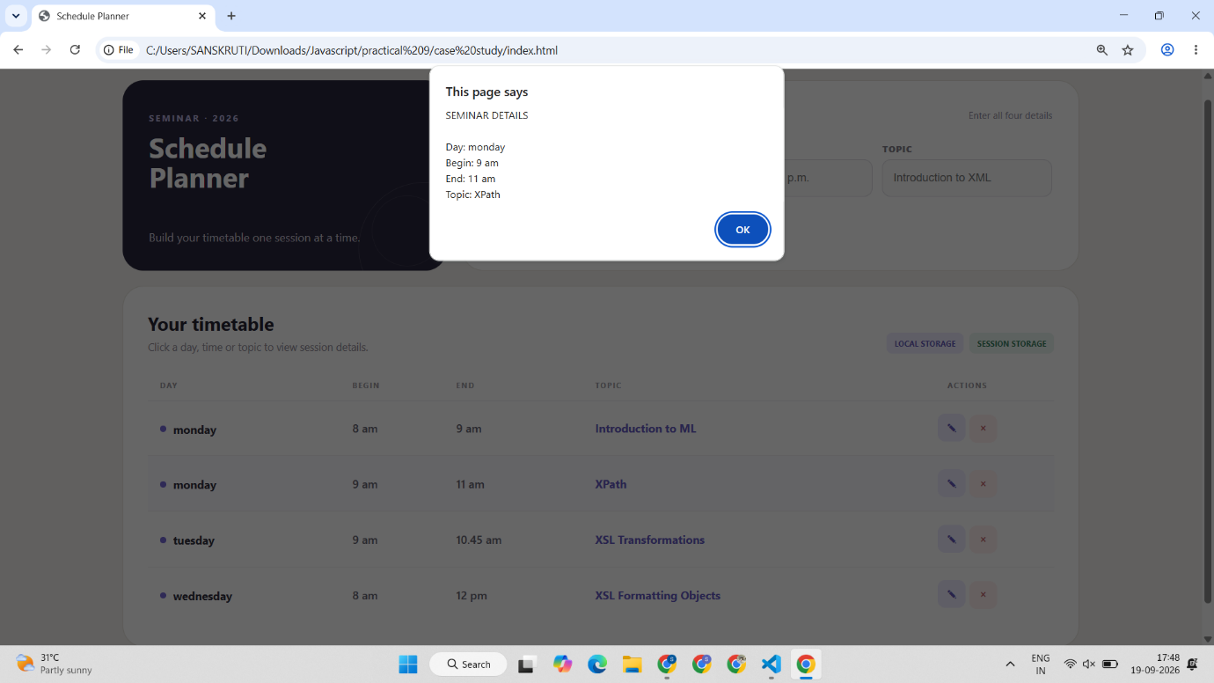
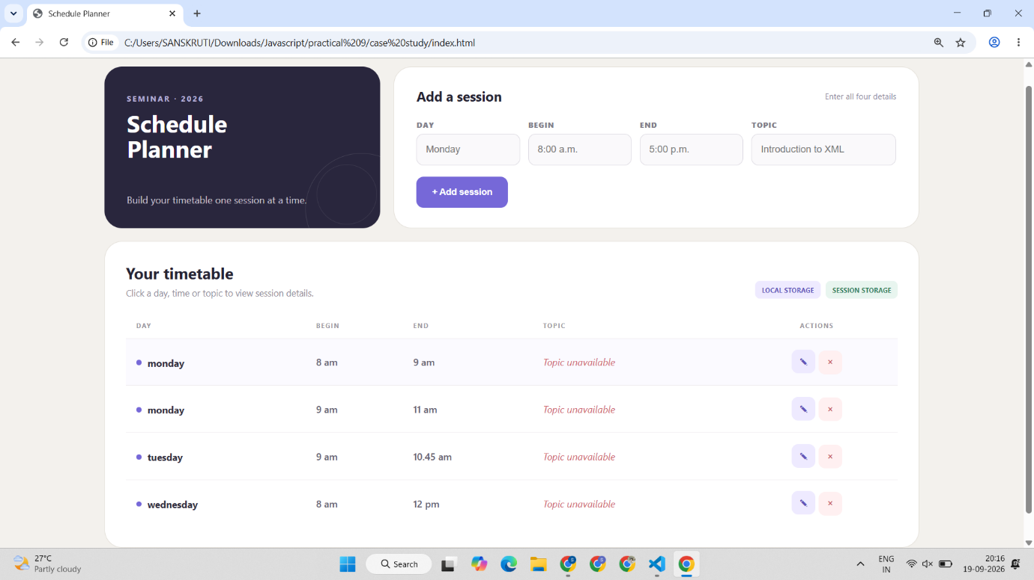
Conclusion –
The experiment successfully demonstrated web storage and JavaScript click events through theme preferences and a Schedule Planner.

